Task 8: Working with VPNs.
Step 1: Choose a reputable free VPN service and sign up.
Here, we have chosen Proton VPN.
Open link: https://protonvpn.com/signup
Choose the free plan and enter details username, password, email id.
Download its free plan for Windows 11.
Step 2: Download and install the VPN client.
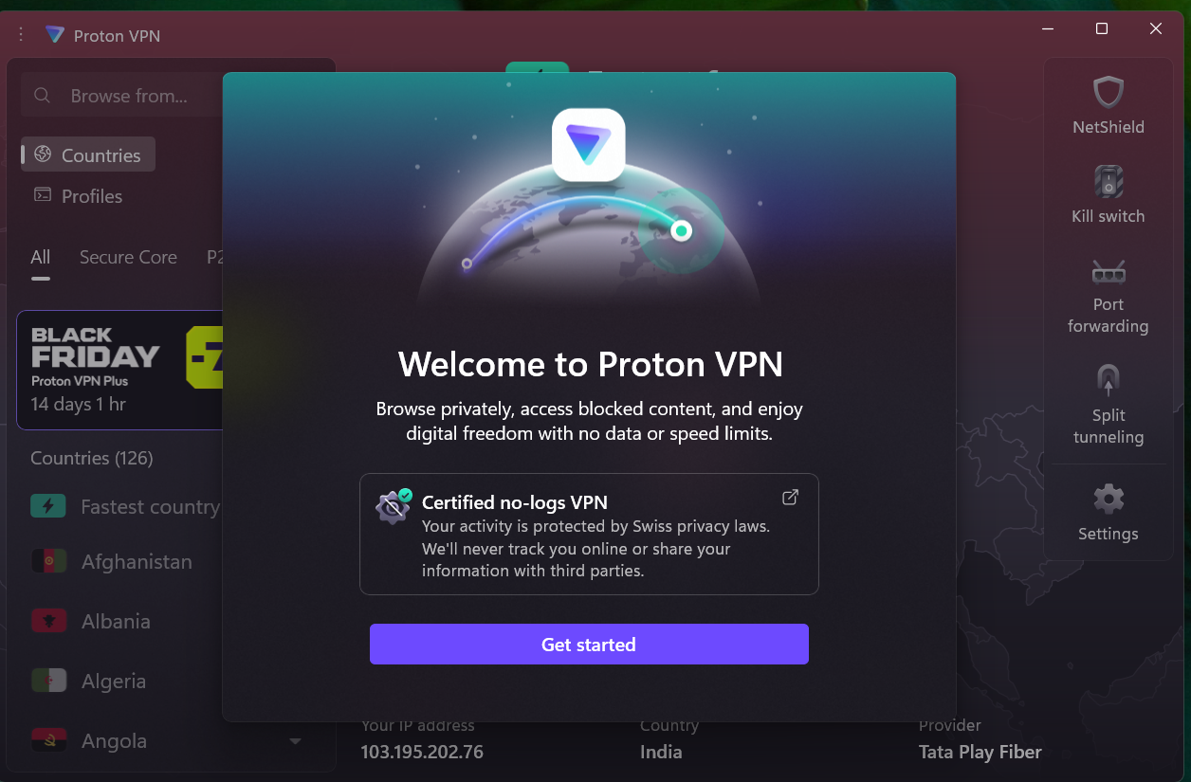
Step 3: Connect to a VPN server (choose closest or any location).
Connected to Netherland’s VPN server.
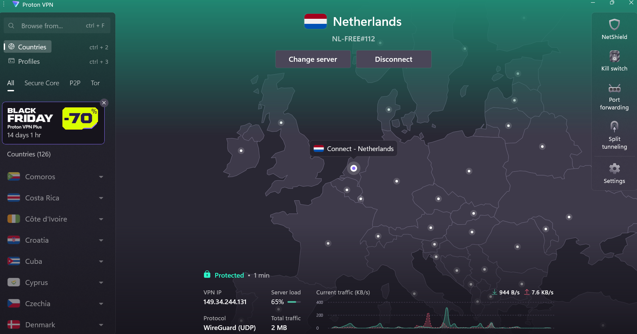
Step 4: Verify your IP address has changed (Use whatismyipaddress.com).
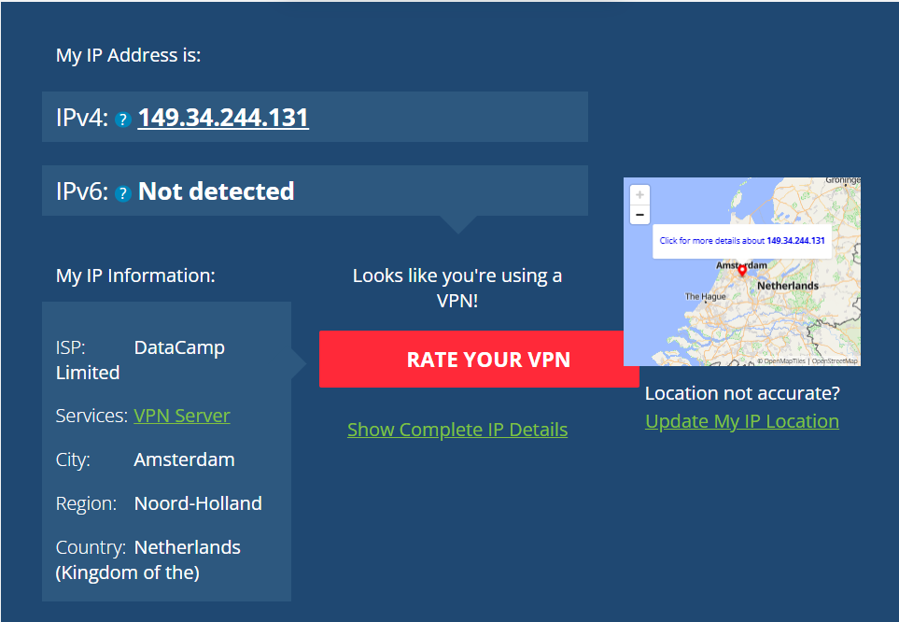
Step 5: Browse a website to confirm traffic is encrypted.
After connecting to the VPN, the browsing speed was slightly slow at first due to encryption and routing through the Netherlands server. However, after a few minutes, the connection stabilized, and websites loaded normally. This shows that VPNs may initially affect speed but maintain secure and stable performance once connected.
Step 6: Disconnect VPN and compare browsing speed and IP.
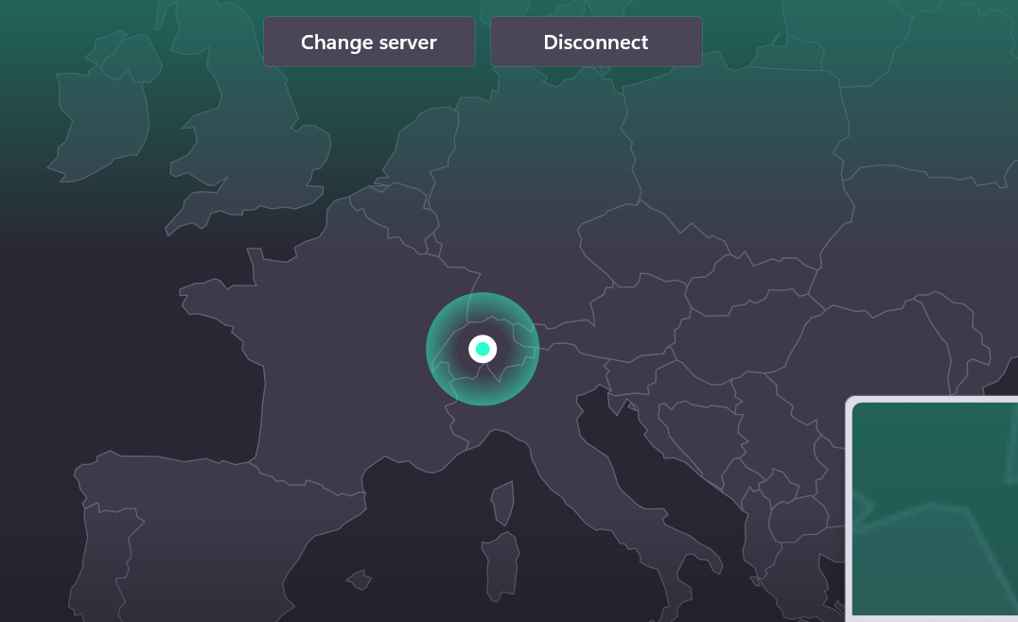
Click on disconnect VPN to disconnect.
Step 7: Research VPN encryption and privacy features.
A Virtual Private Network (VPN) encrypts internet traffic and hides the user’s real IP address, providing privacy and data security. It uses encryption algorithms and tunneling protocols to ensure that no one — not even ISPs, hackers, or government entities — can monitor online activity.
When I connected to the ProtonVPN Netherlands server, my data was encrypted and securely routed through the VPN server before reaching the websites I visited. ProtonVPN uses AES-256-bit encryption, one of the strongest standards used even by governments and financial institutions.
Additional privacy features include:
- IP masking – hides the real IP and replaces it with the VPN server’s IP (in your case, a Netherlands IP).
- No-logs policy – ProtonVPN doesn’t store user browsing activity.
- DNS leak protection – prevents exposure of real DNS requests.
- Kill switch – automatically blocks traffic if the VPN connection drops, keeping you protected.
Step 8: Write a summary on VPN benefits and limitations
Benefits:
- Privacy Protection: Hides real IP and location by routing through VPN servers.
- Data Encryption: Protects all internet traffic from eavesdropping using AES-256 encryption.
- Secure on Public Wi-Fi: Prevents data theft on open or shared networks.
- Bypasses Geo-Restrictions: Lets users access content available only in other countries.
- Prevents ISP Tracking: ISPs can’t see browsing history or throttle connections.
Limitations:
- Reduced Speed: Encryption and routing through distant servers can slow down browsing (you observed this).
- Limited Free Servers: Free plans may restrict country options or speed.
- No Full Anonymity: VPNs hide your IP, but websites can still track cookies or logged-in accounts.
- Connection Drops: If the VPN disconnects, data could be briefly exposed.
- Not a Complete Security Solution: It doesn’t stop phishing, malware, or unsafe downloads.

